
Company
Logotype

Cone Beam Computed Tomography- Report



Porur Dental X-rays & CBCT

Patient Name : Mr. Praveen Kumar | Date of Report : 30.11.2024
Age/ Gender : 44 years/ Male | Region of Interest : CBCT Maxilla
Referring doctor: Dr. Suchithra Mohan | Indication : Periapical lesion 21, 23..?
Clinical Notes: Nil
PATIENT INFORMATION

CBCT Anterior Maxilla provided
CBCT – IMAGE DETAILS

RADIOGRAPHIC INTERPRETATION

- In relation to the periapical aspect of 21, presence of a diffuse periapical hypodense area measuring 5.3 x 6.6 x 6.52 mm in dimension surrounded by a diffuse irregular margin is evident. Presence of a similar hypodense area evident in the periapical aspect of 23, that measures 4.26 x 4.57 x 4.48 mm in dimension.
- The hypodense area appears to cause perforation of the labial cortical plate, lies in close proximity to the nasal floor and incisive canal.
- In relation to the pulp canal of 21, 23, 26 presence of restorative material extending upto the apical third of root is evident.
- In relation to 21, 22, 23, 26 presence of hyperdense crown structure is evident.
- Deviated nasal septum evident.
- Mucosal thickening in relation to the floor of right and left maxillary sinus is evident.

RADIOGRAPHIC IMPRESSION

- Differential Diagnosis (based on the visible radiological features): Periapical pathology in relation to root canal treated 21, 23.


Kindly correlate with clinical and histopathological features

IMAGES FOR REFERENCE

RECONSTRUCTED PANORAMIC VIEW
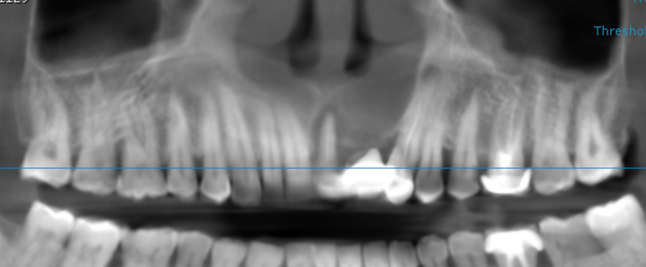

CROSS SECTIONAL IMAGES FOR REFERENCE

21 region

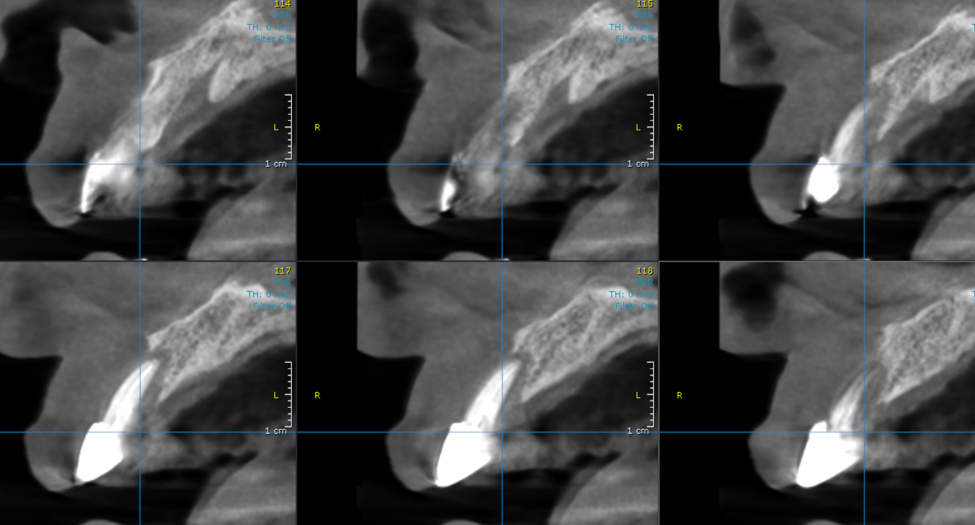

23 region
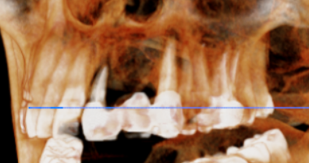
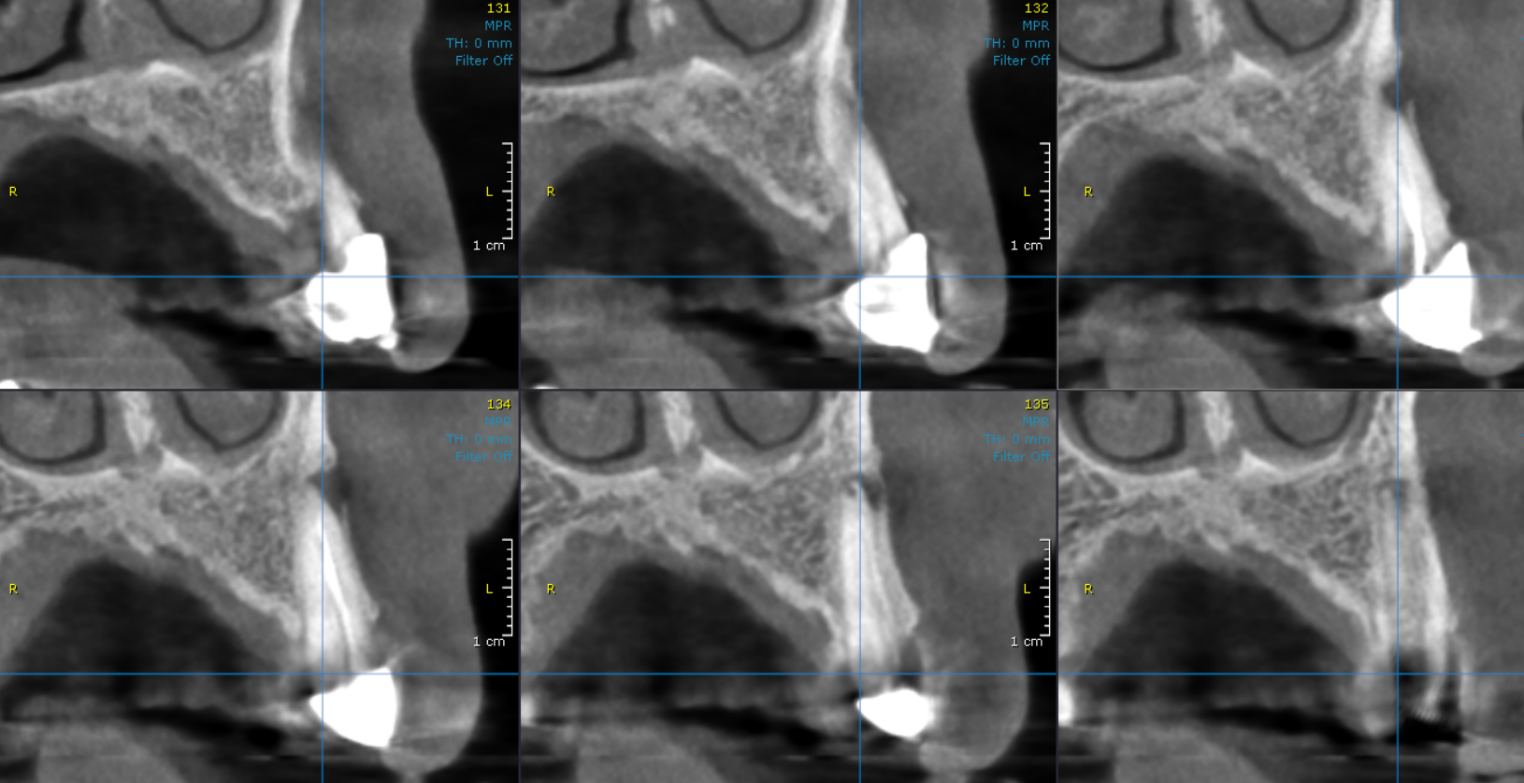
3-DIMENSIONAL VIEW

**** End of report ****

